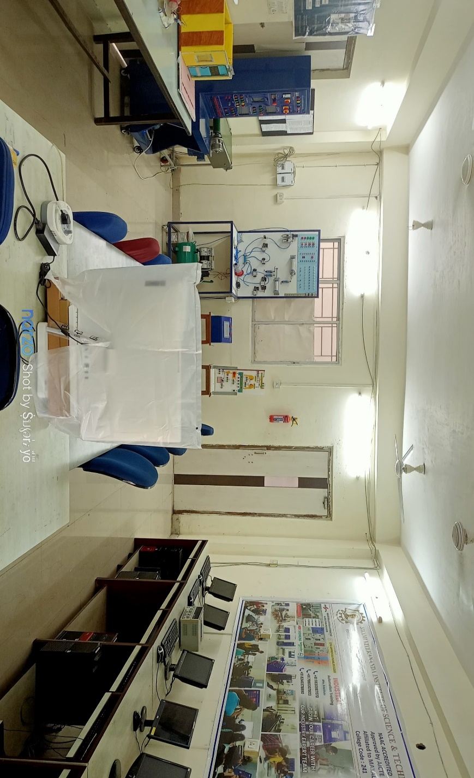

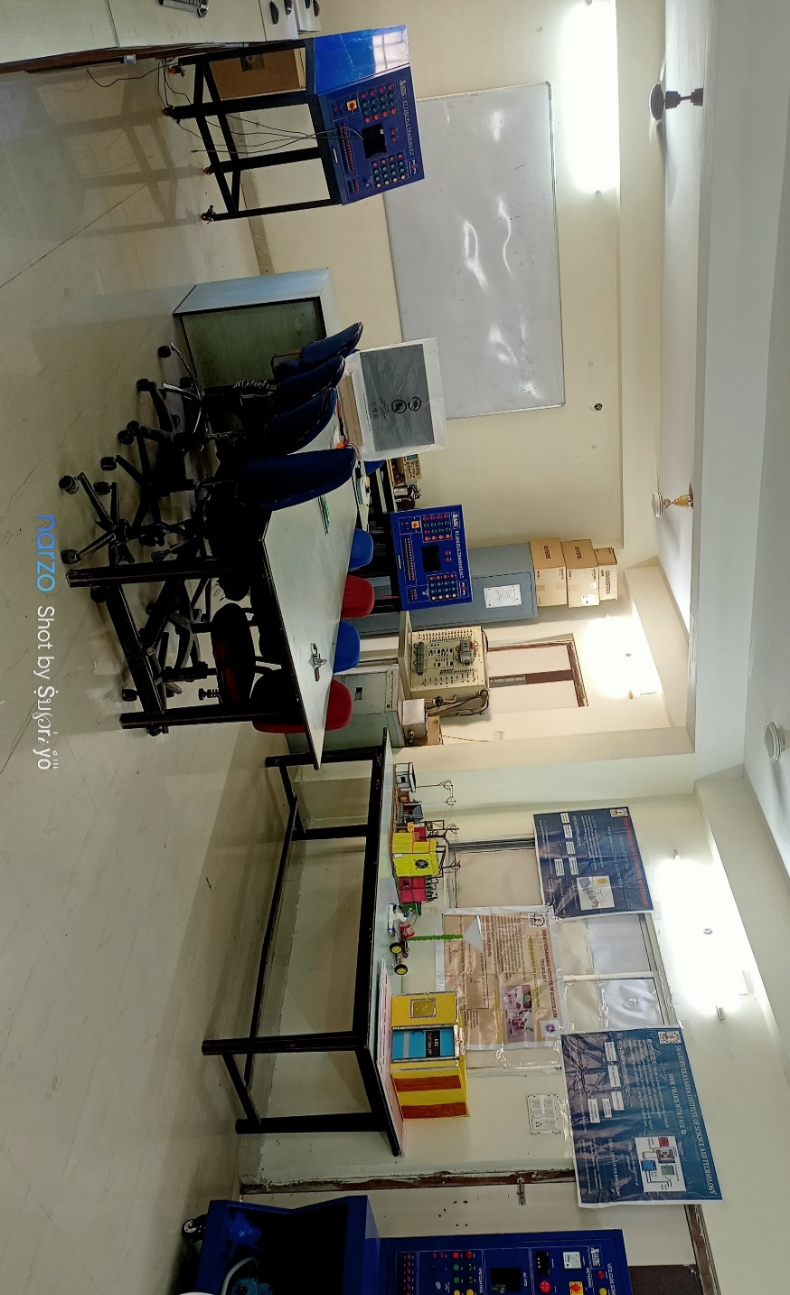

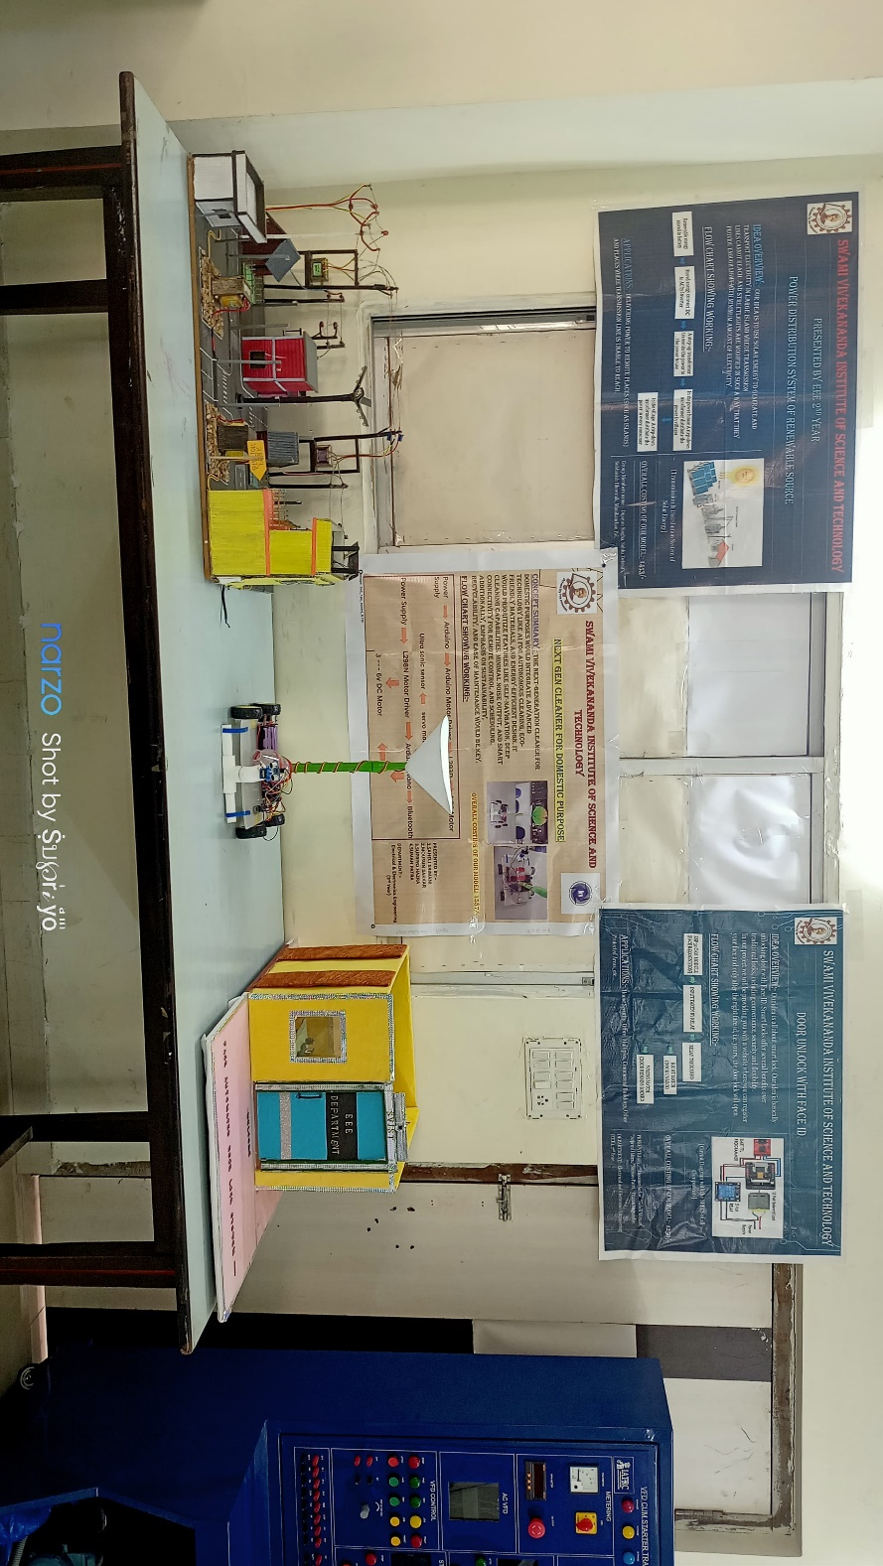

PLC automation Lab, EEE Department

ECE Department

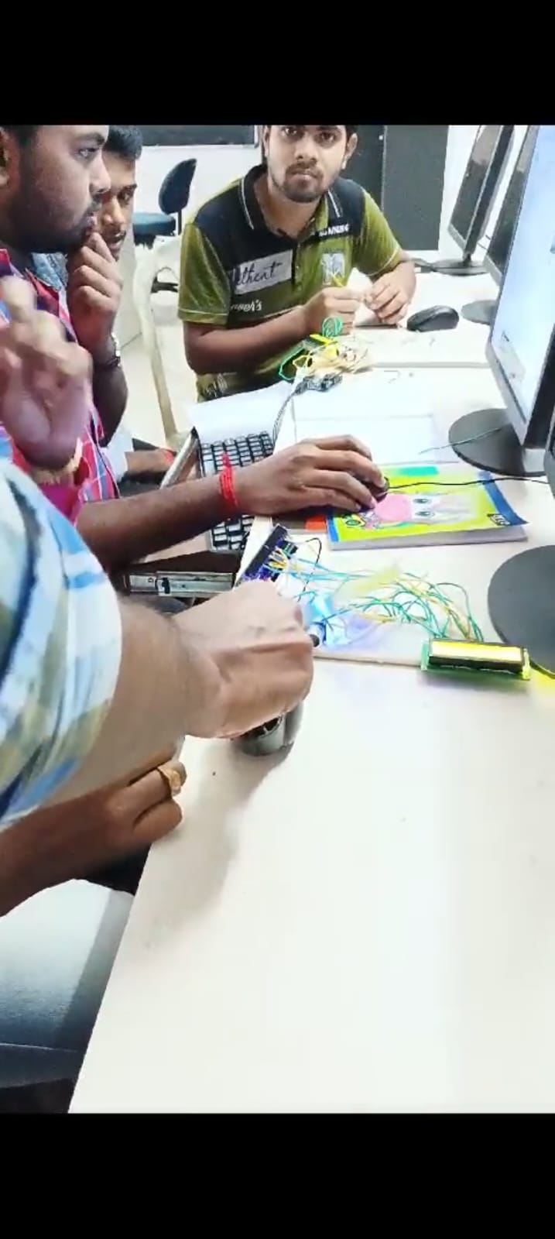

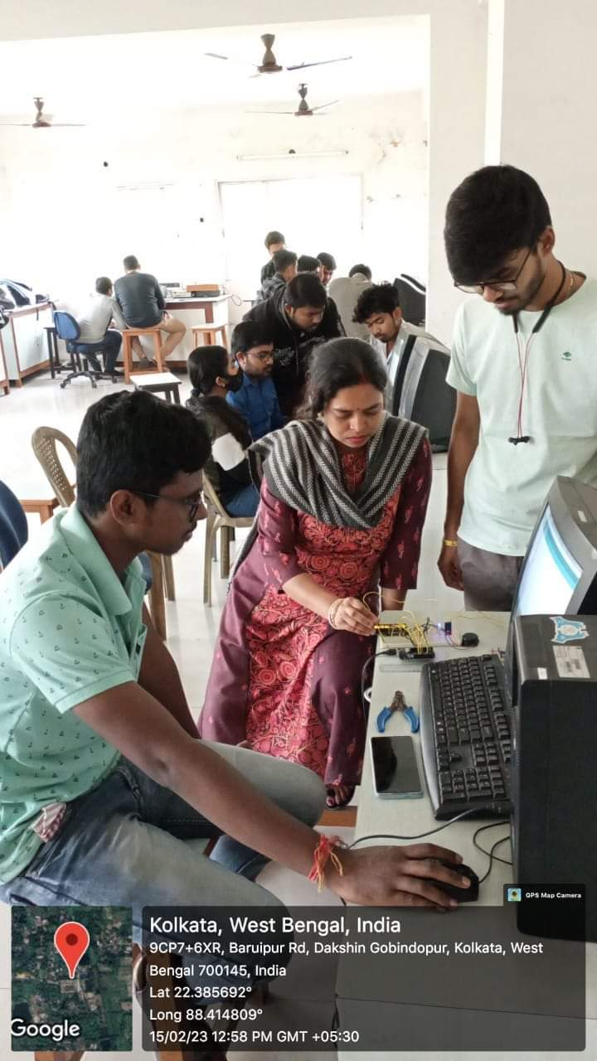

Embedded Lab, ECE Dept.

Robotics Lab, ME dept.

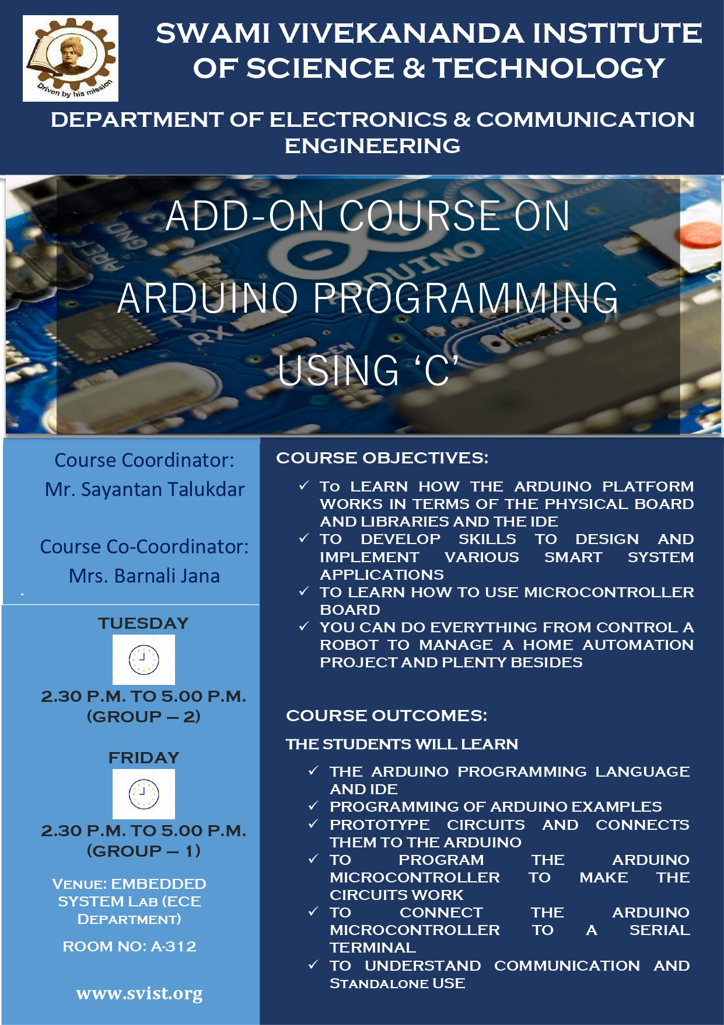

Add on course organized by ECE Dept.

Add on course organized by ME Dept.

Add on course organized by ME Dept.



Add on course organized by EEE Dept.



Add on course organized by EEE Dept.